**HOLIDAY PACKAGE TERM III, 2023 TOP CLASS**

**GENERAL INSTRUCTIONS:**

**1. This Holiday package is composed of all subjects.**

**2. Each subject contains three covered topics of last term.**

**3. All work in each subject shall be marked out of 100mks.**

**4. Parents can assist their children in the project work.**

**5. Parents should ensure that children attempt all questions.**

**6. Diagrams must be drawn in pencils.**

**7. Parents should ensure that the Holiday package comes back when it’s clean.**

**8. Good handwriting will earn you an extra mark.**

**9. Parents should guide the pupils and not to write for them.**

**10. Holiday package shall be submitted in on the first day of Term one, 2024. Any work which will come after the first day shall not be received.**

**11. Holiday package will be counted in the continuous assessment.**

**12. Parents/children who meet any challenges should contact the school for assistance.**

**Name __________________________________**

**Class : __________________________________**

**School :_________________________________**

**LEARNING AREA 4 – (NUMBERS)**

(Developing and using mathematical concepts in my day-to-day experiences)

**Sets**

**A set** is a collection of things/objects.

**1(a) Form small sets of the following.**



**________________**

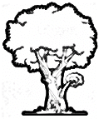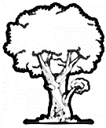

**________________**

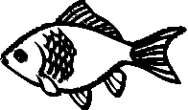



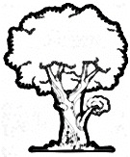

**________________**



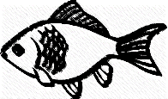

**________________**





**________________**



**________________**

**(b) Name these sets**

a d c

d e f

___A set of letters.___

4 5 6

I 2 3

________________________

tin

cup

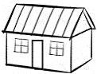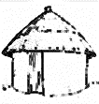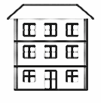 ________________________

mat

Narra Tree Clipart Black And White – Free PNG Images Vector, PSD, Clipart,  Templates ________________________

_

**(c) Add these sets**

9 I0

I 2 3

I I I2

4 5 6

+ =

I3

7 8

g f

a b c

h i

d e

+ =

sit yam

cup rat

tin pot

+ =

good

**2(a) Match the number to the correct word**

I I nine

I3 fifteen

9 sixteen

I5 eleven

I8 thirteen

I6 eighteen

**(b) Write these words in numbers/ figures**

twenty three ______________

thirteen ______________

thirty _________________

twenty nine ______________

forty _________________

nineteen _______________

one hundred ______________

sixty _________________

**3(a) Count and write numbers 75-I00**

|  |  |  |  |  |  |  |  |  |
| --- | --- | --- | --- | --- | --- | --- | --- | --- |
|  |  |  |  |  |  |  |  |  |
|  |  |  |  |  |  |  |  |  |
|  |  |  |  |  |  |  |  |

**(b) Write the next number.**

8I ________ 6I ________

90 ________ 7I ________

7 ________ 88 ________

50 ________ 36 ________

**(c) Put a dot on the number that comes first.**

I 2 55 5

7 8 0 I

I3 I2 38 37

26 25 3

**4(a) Draw these pictures according to their numbers in the big circle.**

One equals an apple

Three equals an egg

Two equals an axe

Five equals an umbrella

Four equals an arrow

**(b) Draw sticks for the numbers below**

6 = I2 =

I = 7 =

0 = I3 =

I6 =

**5(a) Count and add these objects by drawing.**

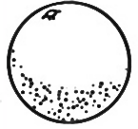 +  = _______________

 +  = _______________ 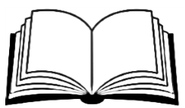 +  = ___________

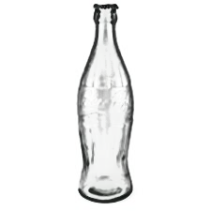 +  = _______________

**(b) Add the numbers.**

6 + I = _______ 7 + 7 = _______

3 + 9 = _______ I + 0 = _______

5 + 0 = _______ 9 + 8 = _______

**(c) Add with words.**

Seven with four equals

Nine and two gives

Five with five equals

Twelve plus ten equals

A tree plus three trees equals trees

**6(a) Name these shapes.**

**6**

**I**

**7**

**2**

I. ______________

2. _____________

3. _____________

4. _____________

5. _____________

6. _____________

7. _____________

**3**

**4**

**5**

oval circle star square triangle

line rectangle zigzag

**(b) Count and write the right number.**

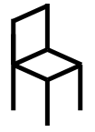 = ________

**VVVVVVVVV** = _________

**ppppppp** = __________

**hhhhhhhhhhh** = __________

**WWWWWWWWWWW** = _________

**7(a) Arrange the numbers in order.**

30 28 26 27 2

______________________________

6 7 8 5 9

_______________________________

99 I00 98 96 97

_______________________________

**(b) Shade the odd man out.**

Sunday Sabath Monday Tuesday

one two 3 four

thirteen fourteen bucket fifteen

**8. Read the days of the week to your parent.**

Sunday Monday Tuesday

Wednesday Thursday Friday Saturday

Questions

a) What is the third day of the week**?**

____________________________________

b) Sunday is the ___________ day of

the week.

c) What is the fifth day of the week**?**

____________________________________

e) Moslems go to the mosque on

____________________________________

f) Christians pray on __________________

**9a) Read the graph below and answer the questions correctly.**

**July**

**June**

**Rain**

**October**

**May**

**March**

**February**

**April**

**November**

**January**

**September**

**August**

30% 50% 50% 0% 50% 80% 80% I0% 20% 65% 40%

Which month had 0% of rain__________

Which two months had 80% of rain**?**

________________ and ________________

August had ________________% of rain.

How many months had 50% of rain**?**

_______________________________________

Write the last month of the year**?**

______________________________________

How many months are on the graph altogether**?**

______________________________________

**10. Tell the time correctly.**

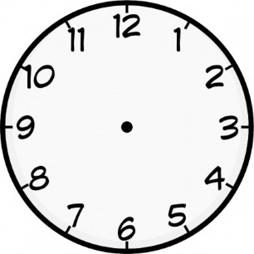 It is ____________ o’clock.

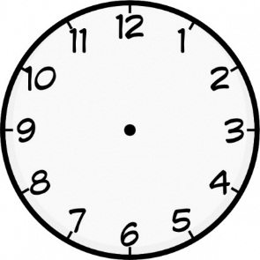 It is ____________ o’clock.

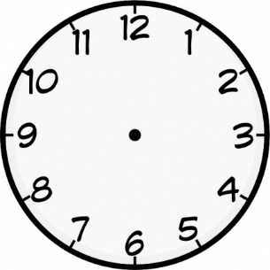 It is ____________ o’clock.

**(b) Show the time.**

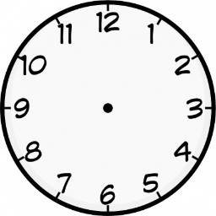 It is  o’clock _

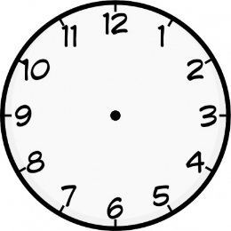 It is **I** o’clock _

 It is **I2** o’clock _

 It is **8** o’clock _

**LEARNING AREA (2) READING**

Developing and using my language appropriately.

**1. Read these vowels correctly.**

**i**

**e**

**a**

**u**

**o**

**Make words from these vowels**

a-t _________ e-nd ________

a-nd ________ e-gg ________

a-m ________ i-s __________

a-rm _______ i-n _________

o-n ________ u-p _________

o-ff ________ u-n _________

o-r ________ u-nder _________

o-x ________ u-mbrella _________

**2. Read these sounds and form syllables**

b-a t-e k-i

y-e h-a s-o

g-u m-a z-o

d-i p-e j-a

f-a n-o l-u

v-u

**3. Read these words and draw picture.**

banana tin zebra

tomato jug soap

key kettle pen

pencil hat fan

**4. Fill the gaps with the correct syllable**

 ____n 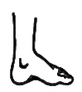____g

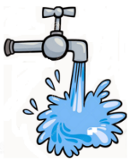 ____p 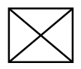 _____x

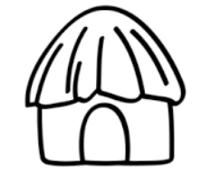 ____t 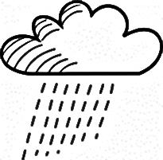 ____in

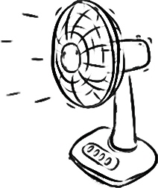 ____n 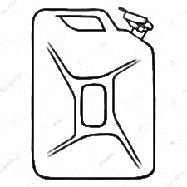____rrycan

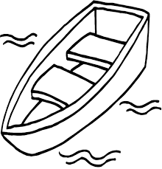 ____at 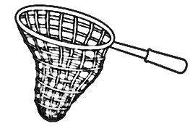 ____t

**5. Read and fill in the missing sounds.**

flower fire fox fan tap tin tree toy mask monkey money man dig den dog dot cup cow can cat

fl___w___r t___y m___nk___y

f____x t___p mon____y

f____r ti____ m____n

fa____ t___e___ ma___k

d___g c___w c____t

c___p d___n d____t

**6. Form words from these sounds.**

|  |  |  |  |  |  |
| --- | --- | --- | --- | --- | --- |
| a | t | b | o | a | t |
| b | o | i | x | f | e |
| g | p | n | e | o | n |
| m | p | e | n | d | t |

(1) ________________

(2) ________________

(3) ________________

(4) ________________

(5) ________________

(6) ________________

**7. Name these pictures.**

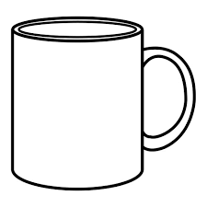_______ 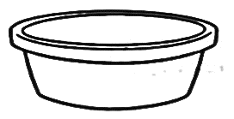_______ 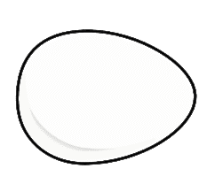______

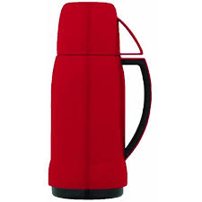________ 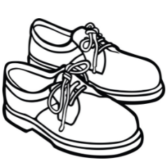_______ 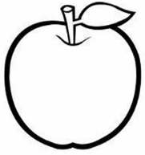_______

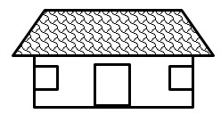_________ _________

 __________ 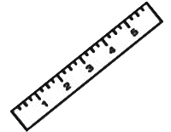 ________

**7. Make sentences from the pictures.**

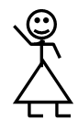 This is a girl. _

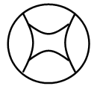 ______________________________

 _______________________________

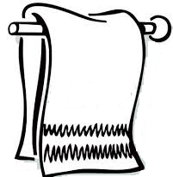 _______________________________

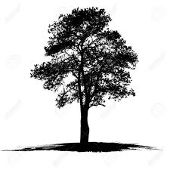 _______________________________

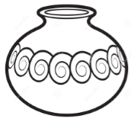 ______________________________

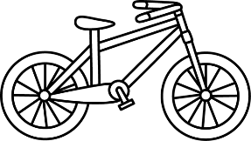 _____________________________

 ______________________________

**8. Complete these sentences correctly.**

A dog lives in the ___________

cattery

stable

sty

hutch

kraal

water

bush

house

nest

kennel

A man lives in the __________

A bird lives in the ___________

A snake lives in the _________

A cow lives in the __________

A pig lives in the ___________

A rabbit lives in the _________

A cat lives in the ____________

A donkey lives in the ________

**10. Read the story and answer correctly.**

My name is Tom. I am three years old. My sister is Nankya. She is in primary four. Nankya is seven years old. Our school is Meritah Christian Junior school.

My name is __________________________.

Tom is _________________ years old.

His sister is called __________________.

Nankya is in primary _________ and she is _________ years old.

Tom and Nankya’s school is ___________

____________________________________.

**11. Draw and colour Tom and Nankya**

**Shade Meritah Christian Christian Junior school**

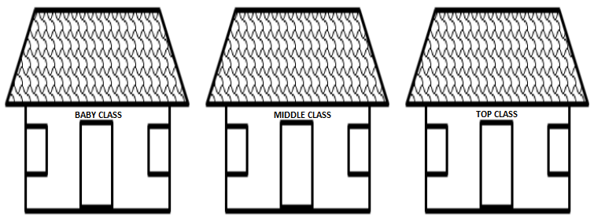

**12. Match animals to their young ones**

A rabbit calf

A dog cub

A cat chick

A lion baby

A hen piglet

An elephant kid

A man lamb

A pig kitten

A goat puppy

A sheep bunny

A cow calf

**13. Match animals to their sounds.**

A cow mwee

A dog baa

A goat quacks

A pig sssss

A snake moo

A duck boo

A sheep mee

A cat grants

**14. Read and colour correctly.**

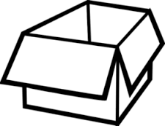red 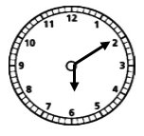 pink

 blue 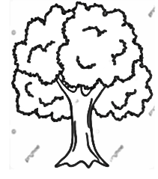 green

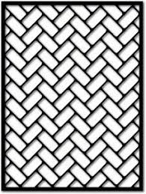 yellow 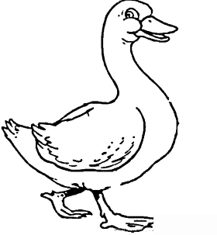 brown

 pupple 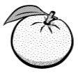 orange

 maroon

***LEARNING AREA (3) GENERAL KNOWLEDGE***

**1. Answer orally as your parents give a tick.**

What is your name**?**

How old are you**?**

In which school are you**?**

Who is the your class teacher**?**

What is the name of your head teacher**?** ______________________________

Who created you**?**

What is the colour of your teeth**?**

How many senses do you have**?**

**2. Name these body parts.**

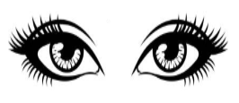 __________ 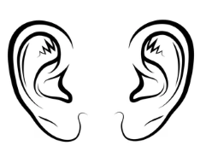 __________

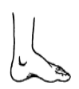 __________ 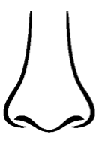 __________

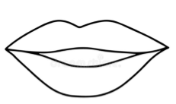 ___________

**3. Name these fruits.**

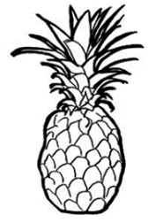 __________ 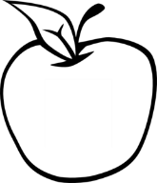 __________

 _________ 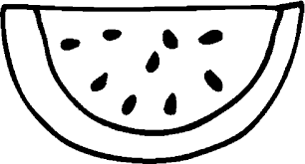 __________

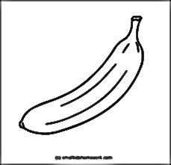 _________ 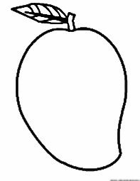 ___________

**4. Fill in the missing letter.**

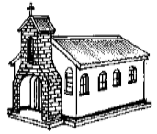 ch__rch  mos__ue

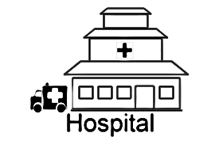 hosp__tal 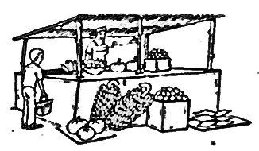 mark__t

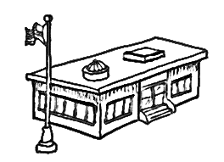 sch__ __l

**5. Read and answer these questions.**

We eat food to get _____________

Before we eat food, we first __________ our hands.

After eating food we ___________ our _____________ and _______________.

(hands, energy, wash, clean, mouth)

**6. Read and draw our food.**

beans fish rice

**7. Read and draw the types of houses.**

tent bungalow flat hut

**8. Name these things created by God.**

 _________ 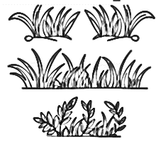 _________

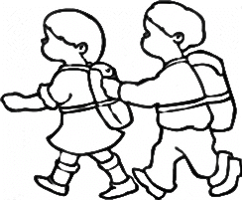 __________ 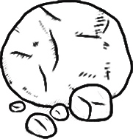 _________

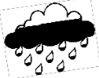 __________ 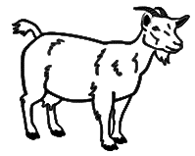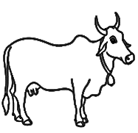 ________

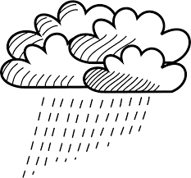 _________ 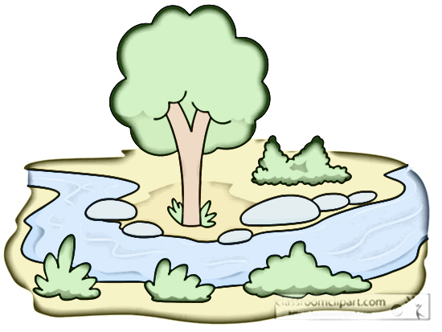 ________

**9. Name these things found at home.**

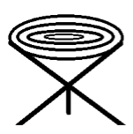 __________ 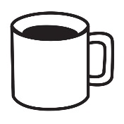 _________

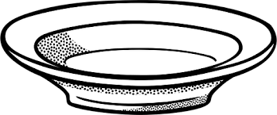 __________ 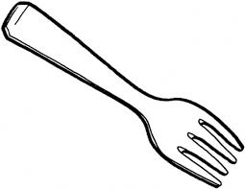 _________

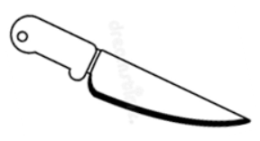 _________ 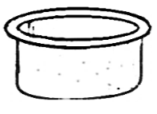 _________

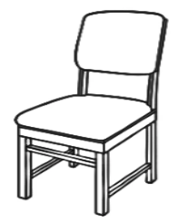 __________ 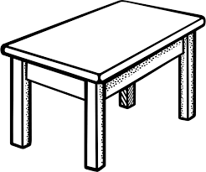 _________

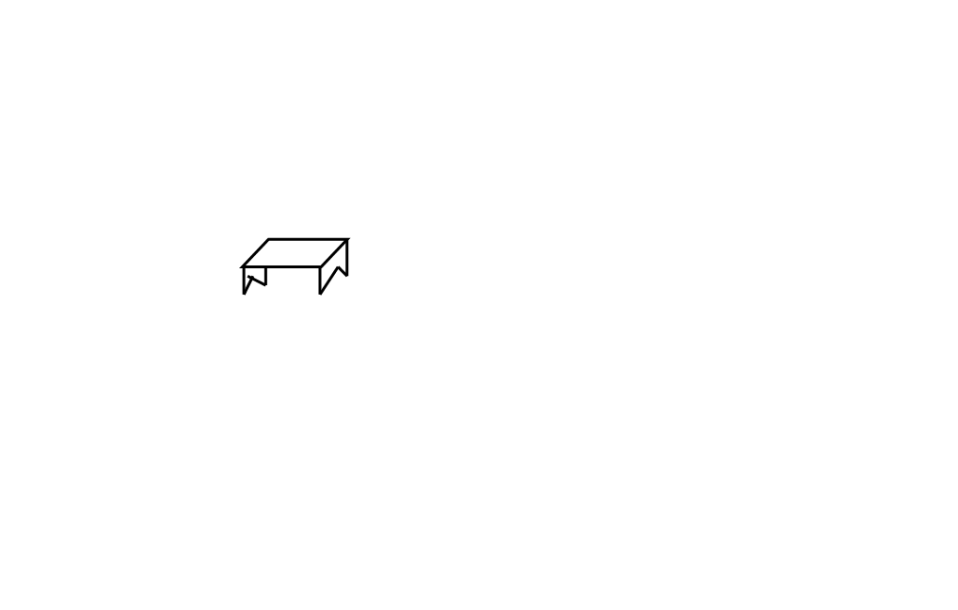 __________ 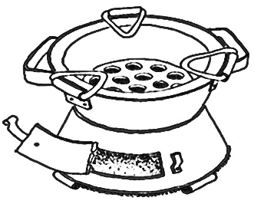 _________

**10.**

Why do we bath _________________

What do we use soap for _____________

We ___________ under treated mosquito nets.

We keep our compound clean by _______________ and ______________

**11. Draw yourself sweeping the compound**

**12. Colour a slasher.**

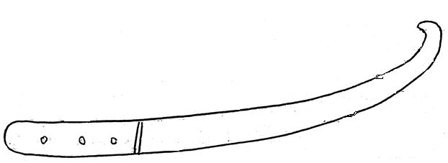

**13. Read and match correctly.**

A doctor removes teeth

A pastor cleans the compound

A farmer teaches children

A cook sewing clothes

A pilot treats sick people

A coblar preaches the Gospel

A tailor digs in the garden

A teacher cooks food

A cleaner flies an aeroplane

A dentist mends shoes

**14. Name these sources of light.**

 _________  _________

_________ 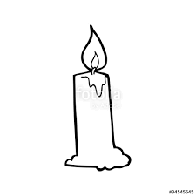 __________

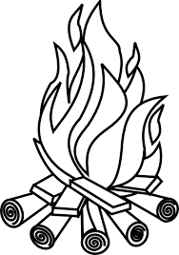 _________  _________

**15**.

Communication is the passing of the messages from one person to another.

We use drums, whistle, bell, phones, television and other things for communication.

**Read and draw.**

bell drum phone

whistle television

**16. Write three Christian names.**

I. __________________

2. _________________

3. ________________

**17. Write three books in the Bible.**

I. __________________

2. _________________

3. ________________

**18. Read and answer correctly.**

When it’s 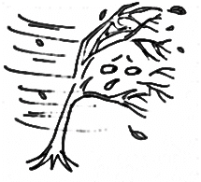the weather is __________

When I feel cold the weather is ____________.

When you see  the weather is _______________.

But when it is very hot  the weather is ________________.

**Draw and colour the sun.**

***LEARNING AREA (5) LANGUAGE***

**1. Match the opposite and write.**

come happy _________

sit dull ___________

laugh wrong _________

boy go ___________

walk stand _________

open cry ___________

correct girl ___________

bright run ___________

sad close __________

**2. Read and write the first letters.**

____B ____D ____J ____F

____ H ____N ____R ____V

____Z ____L ____P ____T

____X

**3. Change these words into capital letters**

sunday ___________ thursday _________

monday __________ friday __________

tuesday __________ saturday _________

wednesday ____________

**4. Fill in the missing letters.**

h___me sto___l buck___t

r___pe p___ppy matook____

l___on m___nk___y gr___ en

mang___es b___rry blu___

j___rryc___n bl___nket w___t___r

b___dro___m kitch___n y___llo___

gr___ndmother pin___apple

**5. Fill the letter in the middle.**

a___c g___i d___f j___l

m___o p___r s___u v___x

y, z

**6. Arrange these letters in order.**

z y x w v u

_______________________________

q p o s r t

_______________________________

**7. Write the letters of alphabet a-z**

**a**

**i**

**r**

**w**

**8. Name these pictures.**

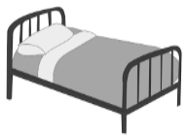 __________ 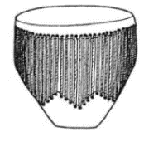 _________

 ___________ 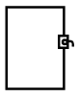 __________

 __________ 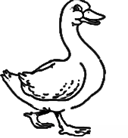 __________

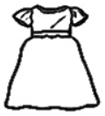 ___________ 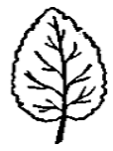 ___________

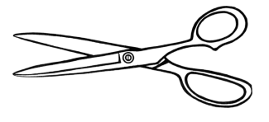 _________  __________

**9. Read and draw.**

FLOWER MATTRESS TELEVISION

RICE TREE FINGERS

STONE SOAP

**10. Read and draw pictures.**

in at on under

over near behind in front

between pointing at

**11. Complete these sentences.**

The ball is ________ the table 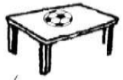

The pencil is ________ the tin 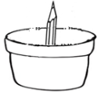

The cup is _______ the pot 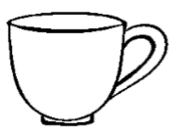 

The bird is flying ________ the tree 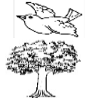

The tin is ________ the table 

The boy is ________ the trees 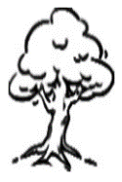 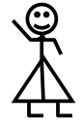 

The girl is _________ at the sun 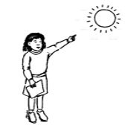

The tree is ________ the house 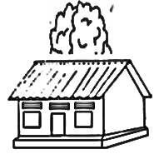

**12. Make sentences from these words.**

He - _________________________________

She - _________________________________

are - __________________________________

a - ____________________________________

is - ____________________________________

They - _________________________________

We - __________________________________

It - ____________________________________

You - __________________________________

an - ___________________________________

**13. Read and draw.**

He is a boy

They are three books

It is a pot

**14. Draw for these words.**

an apple a box a book

an orange an axe a pencil

an arrow an umbrella

**15. Change the words by adding (ing)**

Tom is ___________ the book (read)

Jane is ____________ on the chair (sit)

Isaac is ___________ to school (go)

We are ____________ hands (clap)

Canny is ____________ food (eat)

She is __________ in her book (write)

Peter is ___________ his friend (box)

Stop __________ your friend (kick)

Joan is ___________ her brother (beat)

Tr. Stella is __________ for us (cry)

**16. Read and draw the actions.**

running sitting eating

eating dancing writing

drumming

***WRITING***

**Copy and learn these symbols.**

|  |
| --- |
| **U U U U U U** |
|  |
|  |

|  |
| --- |
|  |
|  |
|  |

|  |
| --- |
|  |
|  |
|  |

|  |
| --- |
|  |
|  |
|  |

**C C C C C C**

|  |
| --- |
|  |
|  |
|  |

|  |
| --- |
|  |
|  |
|  |

**∩ ∩ ∩ ∩ ∩ ∩**

|  |
| --- |
|  |
|  |
|  |

|  |
| --- |
|  |
|  |
|  |

**/ / / / / / /**

|  |
| --- |
|  |
|  |
|  |

|  |
| --- |
|  |
|  |
|  |

|  |
| --- |
|  |
|  |
|  |

**\ \ \ \ \ \ \**

|  |
| --- |
|  |
|  |
|  |

**I I I I I I I I I**

|  |
| --- |
|  |
|  |
|  |

|  |
| --- |
|  |
|  |
|  |

**___ ___ ___ ___ ___ ___**

|  |
| --- |
|  |
|  |
|  |

|  |
| --- |
|  |
|  |
|  |

**O O O O O O O**

|  |
| --- |
|  |
|  |
|  |

|  |
| --- |
|  |
|  |
|  |

|  |
| --- |
|  |
|  |
|  |

**V V V V V V V**

|  |
| --- |
|  |
|  |
|  |

**VVVVVVVVVVVVVVVVVVVVVV**

|  |
| --- |
|  |
|  |
|  |

|  |
| --- |
|  |
|  |
|  |

**vest van volly**

|  |
| --- |
|  |
|  |
|  |

|  |
| --- |
|  |
|  |
|  |

**Vanesa has a vest**

|  |
| --- |
|  |
|  |
|  |

|  |
| --- |
|  |
|  |
|  |

|  |
| --- |
| **Volley has a view very well** |
|  |
|  |

|  |
| --- |
|  |
|  |
|  |

**=// =// =// =// =// =// =//**

|  |
| --- |
|  |
|  |
|  |

|  |
| --- |
|  |
|  |
|  |

**c c c c c c c c c**

|  |
| --- |
|  |
|  |
|  |

|  |
| --- |
|  |
|  |
|  |

**/ / / / / / /**

|  |
| --- |
| **\ \ \ \ \ \ \** |
|  |
|  |

|  |
| --- |
|  |
|  |
|  |

|  |
| --- |
|  |
|  |
|  |

**y y y y y y y**

|  |
| --- |
|  |
|  |
|  |

**o o o o o**

|  |
| --- |
| J J J JJ |
|  |
|  |

|  |
| --- |
|  |
|  |
|  |

|  |
| --- |
| o  J  o  J  o  J  o  J  o  J |
|  |
|  |

|  |
| --- |
|  |
|  |
|  |

***DRAWING AND SHADING***

**1. Draw these things found at church.**

|  |  |  |  |
| --- | --- | --- | --- |
| Rosary | Bible | Cross | Holy table |
|  |  |  |  |

**2. Draw a ball on the chair**

**Colour the cross of Jesus**

**\*\*\*\*\*\*\*\*\*END\*\*\*\*\*\*\*\*\***

**NICE HOLIDAYS**

**MERRY CHRISTMAS & A HAPPY NEW YEAR**

**HEBREWS 12:28-29**

|  |  |
| --- | --- |
| **Date** |  |
| **Parent’s**  **comment** |  |
| **Contact** |  |
| **Signature** |  |